CD.a-n - Colour by design | CD1-11 |

CD.Q Exam questions from past papers
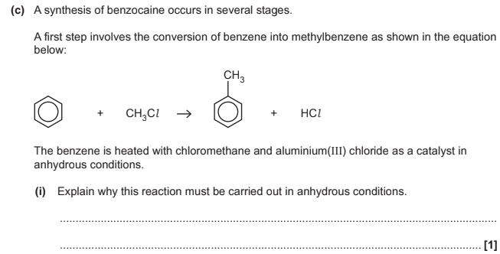  Explain why this reaction must be carried out in anhydrous conditions? | The aluminium (III) chloride reacts vigorously with water
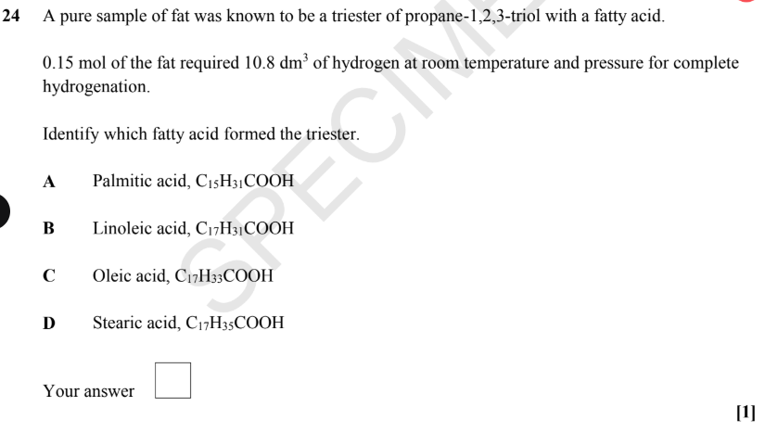  0.15 mol of fat required 10.8dm³ of hydrogen at room temperature and pressure for complete hydrogenation  Identify which fatty acid formed the triester | 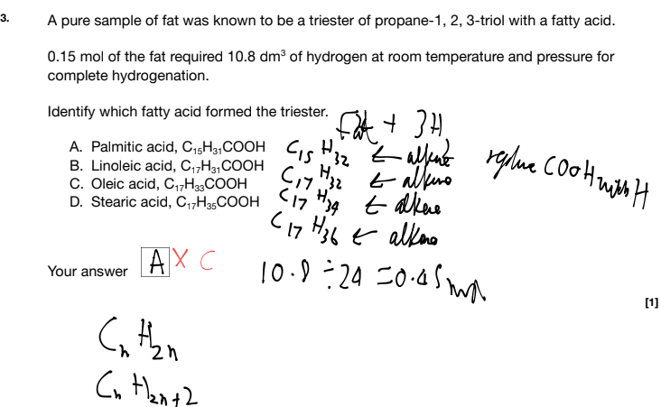  - C as when the COOH group is replaced with H it would be an alkene
Explain why compounds with an aromatic ring usually form substituted derivatives, rather than addition compounds? (1)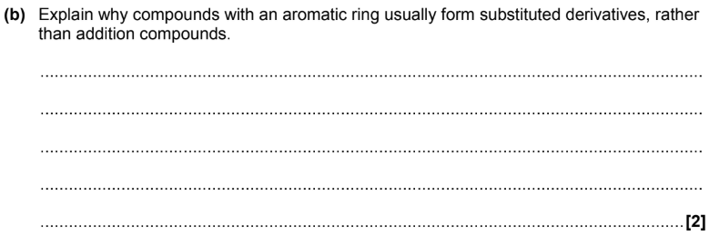 | 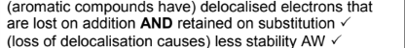  - Aromatic compounds have delocalised electrons that are lost on addition AND retained on substitution (1)  - Less delocalisation causes less stability (1)

CD.a-b - Bonding & Structure | CD5 | CD6 |
Define Colorfast dye? | A dye that doesn’t wash out easily
What are the 4 different ways dyes attach themselves to fibres? | - Ionic bonds (between dyes and nylon,wool or silk)  - Covalent bonds (between dyes and cotton, cellulose)  - Hydrogen bonds (between dyes and cotton)  - Id-id bonds (dyes and polyesters)  Mordanting as well in the textbook never seen it in past paper though
What are the ways in which dyes bond to fibres and the functional groups to which this occurs? | - Ionic bonds via -COOH or -SO₃H group on a dye and a -NH₂ group in fibres (fibres such as wool, silk or nylon)  - Strong covalent bonds forming via fibre-reactive dyes bonding with -OH or -NH group in the fibre (cotton, cellulose)  - Hydrogen bonds via -NH₂ groups on a dye and a -OH group on a fibre (cellulose fibres such as cotton, rayon or linen )  - Dissociation of ionic groups then forming ionic bonds via dyes having -SO3⁻Na⁺ and dissociating in water to produce -SO₃⁻ group and then -NH₂ group on the fibre (nylon,wool silk) which in the presence of an acid produces -NH₃⁺ which then -SO₃⁻ binds with -NH₃⁺  - Acidic conditions (i.e in a weak acid) could also mean -NH₂ groups become protonated and turn into -NH₃⁺ on either dye or fibres  All of these are types of examples for which a dye could bond to a fibre it does not represent all the ways so make sure to interpret a question carefully bestie
Define Chromophore? | A part of a molecule that is responsible for the colour of a substance  It does this by changing the wavelength the electrons absorb and they usually contain: double or triple bonds like C=C or N=N, lone pair of electrons or benzene rings  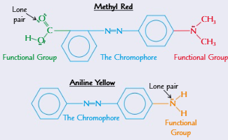
Which atoms as part of the functional group on the chromophore/azo dye changes the colour of the azo dye and why? | - Oxygen and Nitrogen atoms lone pair of electrons (mostly likely from an -OH or NH₂ group)  - As these groups have lone pair of electrons that become part of the extended system of delocalised electrons that spans between the two benzene rings and the -N=N- group  - They change the frequency of light they absorb and so the colour of the molecule  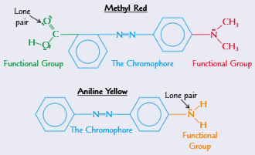
Which functional groups on the chromophore affect the solubility of the dye AND what is the name of that functional group (1) | - Usually ionic groups such as SO₃⁻ (usually in the form of its sodium salt e.g -SO₃⁻Na⁺)  - As the SO₃⁻ group can form ion-dipoles with water molecules which is stronger than hydrogen bonds from an -OH or -NH₂ group  - SO₃⁻ is a sulfonate group (1)  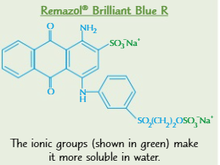

CD.c-f - Organic functional groups | CD2 | CD3 | CD4 | CD7 | CD10 |
What are triglycerides? | They are triesters of glycerol (propane-1,2,3-triol) and (unsaturated or saturated) fatty acids  They usually ask about condensation or hydrolysis reactions to do with these, make sure to balance the equations correctly and a long chain group might be represented using R e.g RCOOH or K+ e.g KOH  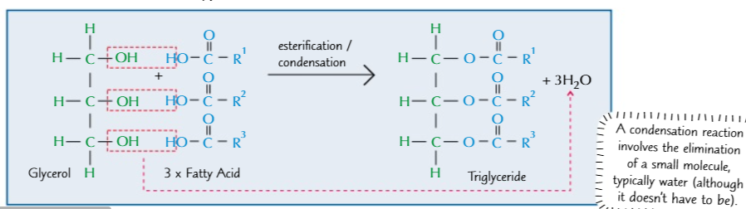
How does a fatty acid/ triglyceride(triester) being unsaturated affect its melting point | The melting point would be lower as the fatty acid would do E/Z isomerism and so would have a ‘kink’ in the chain which pushes the chains apart allowing for less id-id bonds to form 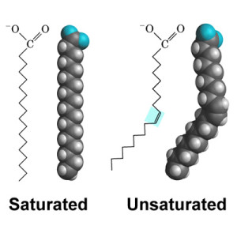
What are the names for these 6 arenes?  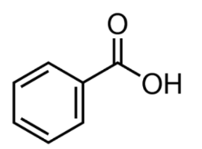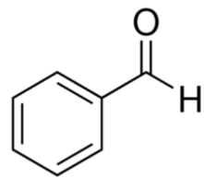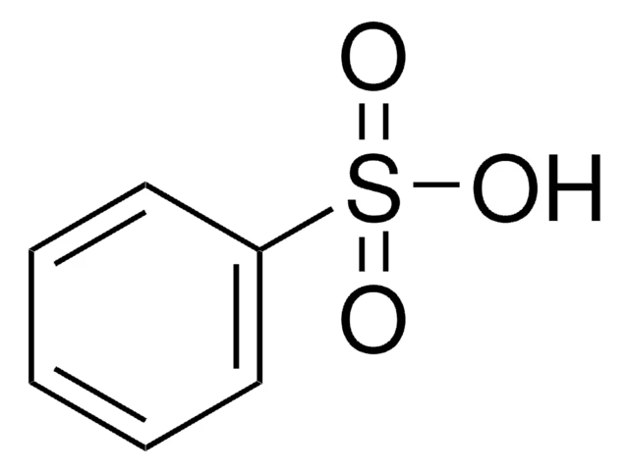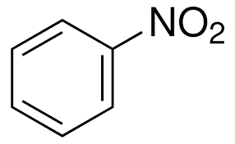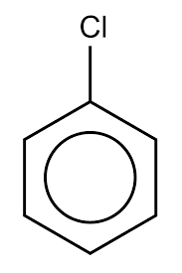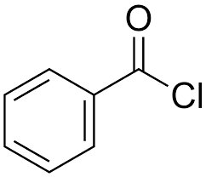 | - Benzoic acid  - Benzaldehyde  - Benzene sulfonic acid  - Nitrobenzene  - Chlorobenzene  - Benzoyl chloride
What does the actual structure for benzene look like? (2) | - 2 rings of 6 delocalised electrons (1) above and below the ring of carbon atoms (1) where 1 delocalised electron comes from each carbon  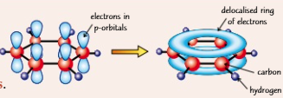  The pi ring or the sideways overlapping of the 6 p orbitals means low electron density therefore benzene is unable to polarise many molecules requiring catalysts
What was wrong with kekule’s benzene structure and why is the current/actual benzene structure correct? (4 reasons for each structure)  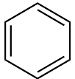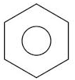 | Kekules’s Structure  - Not hexagonal  - Should undergo electrophilic addition as it has C=C bonds  - It would decolourise bromine water  - Enthalpy change of hydration should be -360kJ/mol as its -120 per double bond x 3  - Bond lengths would not be the same (as C=C is shorter than C-C therefore 3 short bonds 3 longer ones)  - There would have been 2 isomers if kekule’s  Benzene structure  - Hexagonal  - All bonds same length  - Actually undergoes electrophilic substitution reactions (as it keeps more stable delocalised structure)  - 2 rings of delocalised electrons above and below the carbon atoms  - Each atom in the ring contains 1 lone electron (delocalised electron)  - Enthalpy change of hydration is actually -208kJmol⁻¹  - Actual benzene has 1 isomer  - Energetics suggest actual benzene would be more stable than kekule’s  - Its electron density maps  - Actual benzene needs ‘forcing’ conditions to undergo addition  Don’t talk about bond angles as they are the same 120° for both structures  Italics are fine details  Based of H433 Paper 3 June 2023 6 marker
Functional group of diazonium salt and draw benzenediazonium chloride? | - Functional group  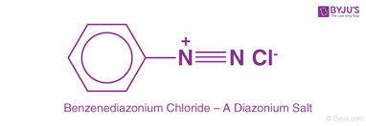  - Benzenediazonium chloride
Functional group of azo dye? | - Functional group  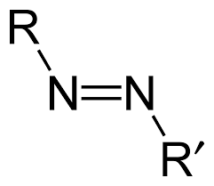  Usually two or more benzene rings on either R group as dyes as coloured and more than 1 benzene ring is needed for an extended system of delocalised electrons to be coloured
Functional group of Nitrile and why is forming them via nucleophilic substitution often useful | - Functional group  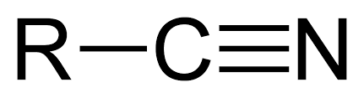  Its useful as it creates an extra carbon along the organic chain  Usually related to nucleophilic addition or substitution

CD.g-j - Organic Reactions | CD4 | CD5 | CD9 | CD10 | CD11 |
What are the conditions, reagents, products and the equation for the formation of electrophile for the chlorination of benzene? | - Conditions: Anhydrous, Heating under reflux  - Reagents: Cl₂ and AlCl₃ as a catalyst  - The halogen carrier (AlCl₃) polarises the chlorine allowing it to react with the halogen carrier to form a positive electrophile  - AlCl₃ + Cl₂ -> AlCl₄⁻ + Cl⁺  - React the electrophile with the benzene  - Products: Chlorobenzene, HCl  A positive electrophile has to be formed because benzene isn’t very polarising  Mechanism: Electrophilic Substitution
What are the conditions, reagents, products and the equation for the formation of electrophile for the bromination of benzene? | - Conditions: Anhydrous, Heating under reflux  - Reagents: Br₂ and FeBr₃ as a catalyst  - The halogen carrier (FeBr₃) polarises the bromine allowing it to react with the halogen carrier to form a positive electrophile  - FeBr₃ + Br₂ -> FeBr₄⁻ + Br⁺  - React the electrophile with the benzene  - Products: Bromobenzene, HBr  A positive electrophile has to be formed because benzene isn’t very polarising  Mechanism: Electrophilic Substitution
What are the conditions, reagents, products and the equation for the formation of electrophile for the nitration of benzene? | - Conditions: below 55℃  - Reagents: Conc HNO₃, conc H₂SO₄  - Formation of the electrophile nitronium ion  - Overall: H₂SO₄ + HNO₃ -> HSO₄⁻ + NO₂⁺ + H₂O  - React nitronium ion with benzene…  - Products: Nitrobenzene, H₂O  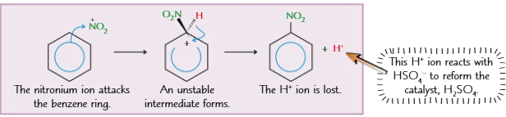  The catalyst H₂SO₄ has reformed. You need concentrated conditions  Perform within a water bath as reaction is exothermic. Any temperature too high will lead to polynitration rather than mononitration  Mechanism: Electrophilic Substitution
Draw the mechanism for the nitration of benzene | Reagents: Conc HNO₃, conc H₂SO₄  Overall: H₂SO₄ + HNO₃ -> HSO₄⁻ + NO₂⁺ + H₂O
What are the conditions, reagents, products and the equation for the formation of electrophile for the sulfonation of benzene? | - Conditions: Heating under reflux  - Reagents: Concentrated H₂SO₄  - Formation of the electrophile sulfonate (sulfur trioxide)  - H₂SO₄ -> H₂O + SO₃  - Products: Benzenesulfonic acid, H₂O  Reagents and conditions could also be fuming sulfuric acid and 40℃ instead  Mechanism: Electrophilic Substitution
What are the conditions, reagents and products for Friedel-Crafts alkylation of benzene as well as the equation for the formation of the electrophile? | - Conditions: Anhydrous, heating under reflux  - Reagents: AlCl₃ (halogen carrier) , CH₃Cl  - Formation of Electrophile: CH₃Cl + AlCl₃ -> CH₃⁺ + AlCl₄⁻  - Products: Methylbenzene, HCl  Mechanism: Electrophilic substitution
What are the conditions and reagents for Friedel-Crafts acylation of benzene as well as the equation for the formation of the electrophile? | - Conditions: Anhydrous  - Reagents: CH₃COCl and AlCl₃  - Formation of Electrophile: CH₃COCl + AlCl₃ -> [CH₃CO]⁺ + [AlCl₄]⁻  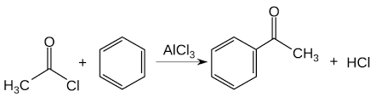  Names of products for acylation is not required for our spec  Mechanism: Electrophilic substitution
What are the conditions, reagents, products for diazotisation of aminobenzene?  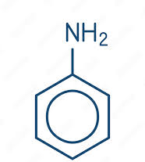 | - Conditions: below 5℃ (ice cold)  - Reagents: Aminobenzene, HNO₂ (or NaNO₂), HCl  - Products: diazonium salt (Benzenediazonium chloride), H₂O  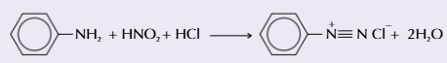  If NaNO₂ is used instead of HNO₂ products would be diazonium salt, NaCl and H₂O just check that the equation is balanced and if the regents are in excess  Diazotisation needs to be kept separate from a coupling reaction as diazotisation requires acidic conditions and coupling requires alkaline conditions.  Mechanism: Electrophilic substitution
What are the conditions, reagents, products and coupling agent for the coupling reaction for making an azo dye? | - Conditions: below 5℃ (ice cold)  - Reagents: NaOH, diazonium salt (Benzenediazonium chloride)  - Coupling agent: E.g phenol (could also be considered to be another reagent)  - Products: azo dye, HCl  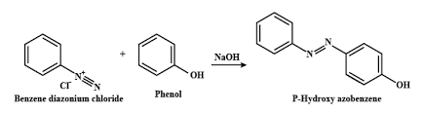  Don’t ever forget that it needs to be in alkaline conditions  An Asterisk * is OFTEN used to show where a coupling agent would most likely bond to reagent; don't assume it could bond on any part of the benzene ring. Sometimes but not always if the coupling agent is e.g. phenol then it would bond on the opposite side of 1 benzene ring to the -OH bond as shown above  Diazotisation needs to be kept separate from a coupling reaction as diazotisation requires acidic conditions and coupling requires alkaline conditions.  You don’t need to know how to name azo dyes so relax  Mechanism: Electrophilic substitution
What are the reagents, and conditions for forming carboxylic acids from aldehydes? | - Acidified potassium dichromate (VI) (ADP)  - Heating under reflux
What are the 3 laboratory tests that could be done to distinguish between an aldehyde and a ketone and what is observed for each? (2) | - Warm with acidified potassium dichromate (1) turns from orange to green (1)  - Warm with Tollen’s reagent (1) turns from colourless to a silver mirror (1)  - Warm with Fehling’s solution (1) solution turns from blue to a red/orange ppt (1)  In all 3 cases the aldehyde is being oxidised to make a carboxylic acid ketone would never be oxidised  The word ‘Warm’ is a necessity  Tollen’s reagent is also known as ammoniacal silver nitrate  Benedict's reagent can be said/used instead of Fehling’s solution
How can carbonyls (ketones/aldehydes) become hydroxynitriles with reagents and conditions and what is the name of the functional group formed in the product (1) ? | - Reagents: HCN  - Conditions: RTP  - Cyanohydrin (1)  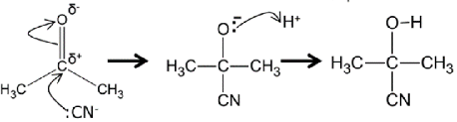  H⁺ ion from HCN  Cyanohydrin and hydroxynitrile are both names for the functional group  HCN is highly toxic  Mechanism Nucleophilic Addition
What are the reagents, conditions, products and type of reaction for forming nitriles from haloalkanes? E.g. HBr  [Its on the data sheet] | - Conditions: Heating under reflux  - Reagents: NaCN, ethanol  - Products: nitrile, NaBr  - Type of reaction: Nucleophilic substitution  IT'S ON THE DATA SHEET
How are carboxylic acids formed from nitriles (Conditions, reagents, type of reaction)  [Its on the data sheet] | - Conditions: Heating under reflux  - Reagents: HCl  - Type of reaction: Hydrolysis  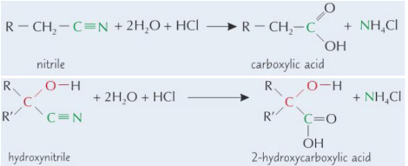  IT'S ON THE DATA SHEET
How are carbonyls reduced to alcohols? (reagents and type of reaction)  [Its on the data sheet] | - NaBH₄  - Reduction  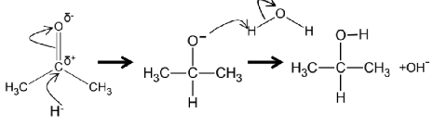  IT'S ON THE DATA SHEET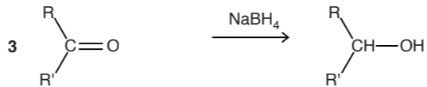
How are acyl chlorides formed from carboxylic acids (catalyst, conditions, type of reaction)  [Its on the data sheet] | - By reacting Carboxylic acid with SOCl₂  - RTP  - Type of reaction: substitution  - CH₃COOH + SOCl₂ -> CH₃COCl + SO₂ + HCl  IT'S ON THE DATA SHEET
How is aminobenzene formed from nitrobenzene? (reagents, conditions and type of reaction)  [Its on the data sheet] | - Sn and conc H₂SO₄  - Heat under reflux  - Reduction  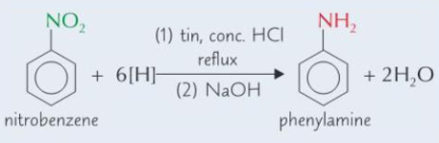  IT'S ON THE DATA SHEET  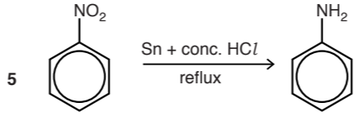
What are the reagents, conditions and products for forming haloalkanes from alcohols (e.g ethanol and HBr)? | - NaBr, conc H₂SO₄  - Heating under reflux  - Haloalkane + H₂O  Occurs via:  - NaBr + H₂SO₄ -> NaHSO₄ + HBr  - E.g CH₃CH₂OH + HBr -> CH₃CH₂Br + H₂O  Mechanism: Nucleophilic substitution
What are the reagents, conditions, products and type of reaction for forming amines from haloalkanes? E.g R-Br | - Conditions: Heat in a sealed tube  - Reagents: NH3, ethanol  - Products: R-amine, HBr  - Type of reaction: Nucleophilic substitution
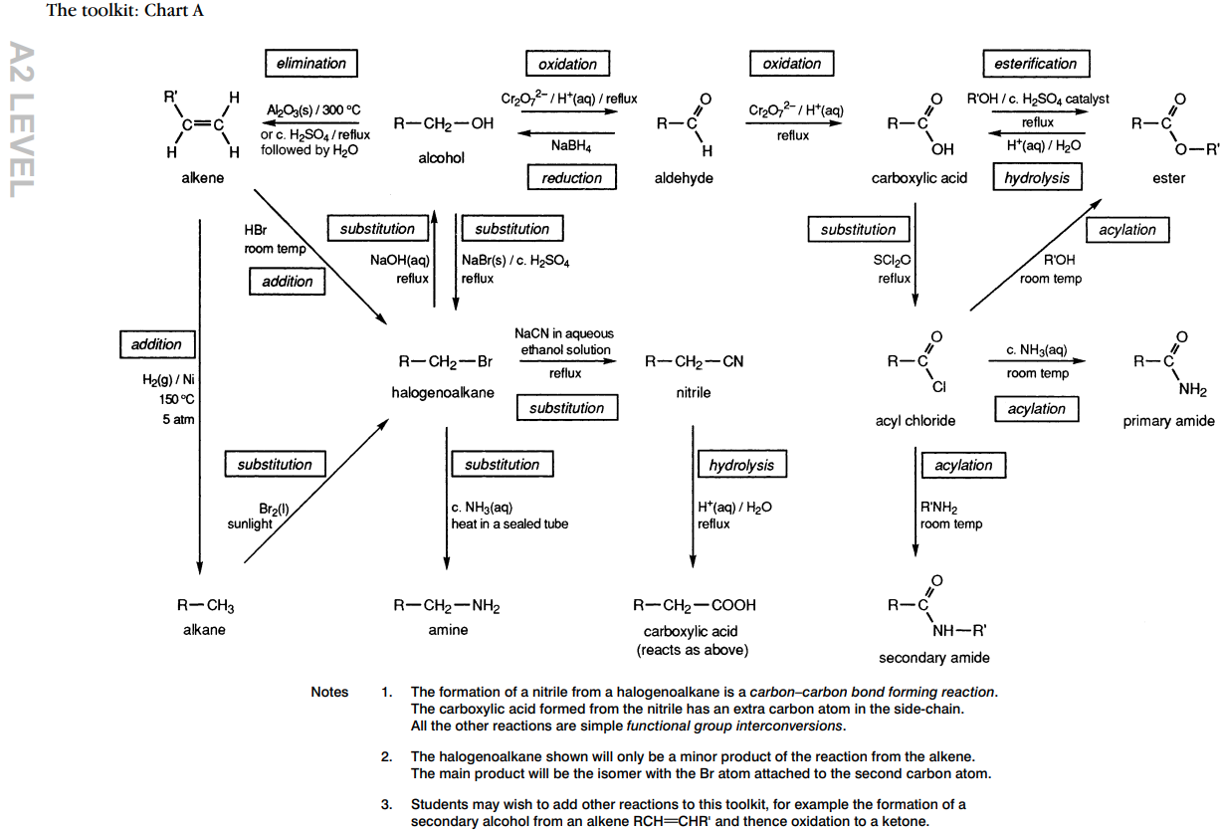
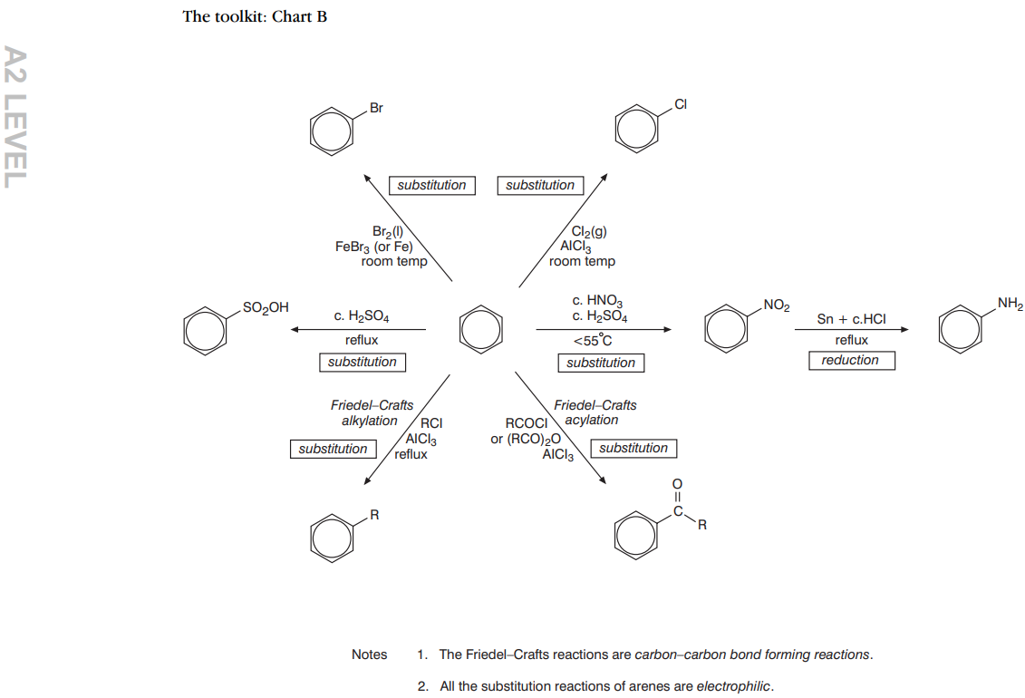
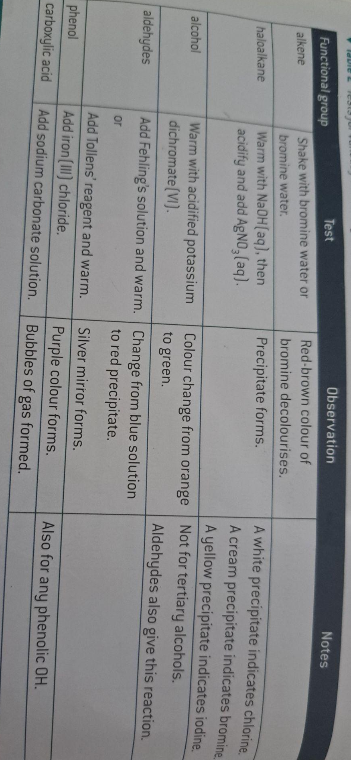
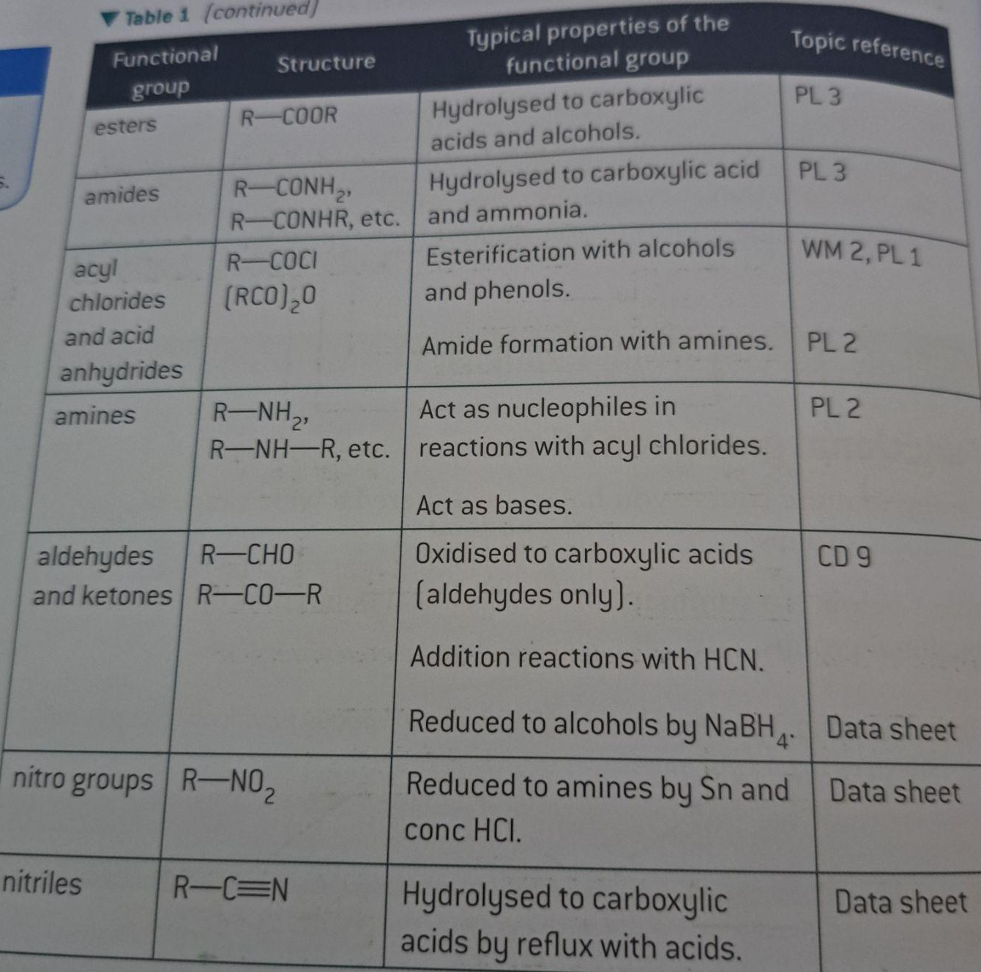
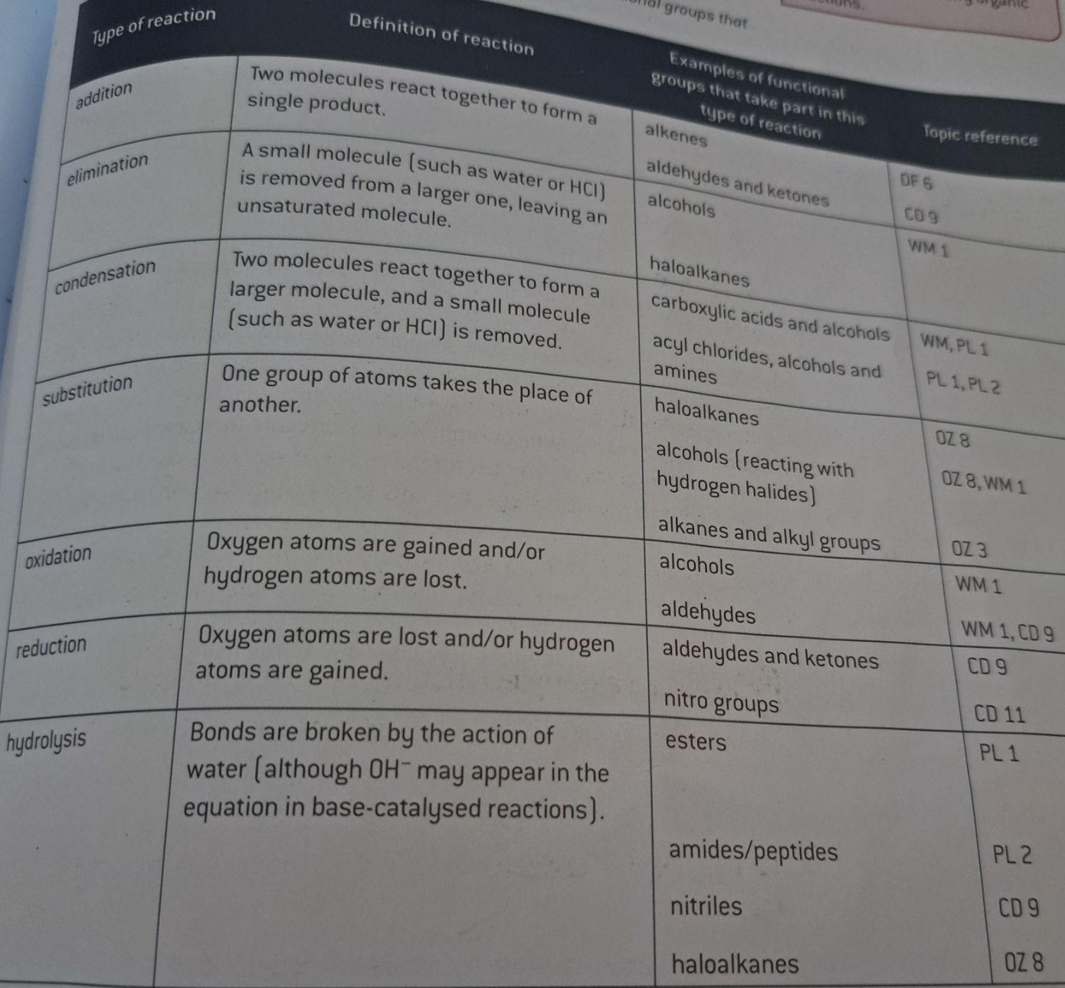
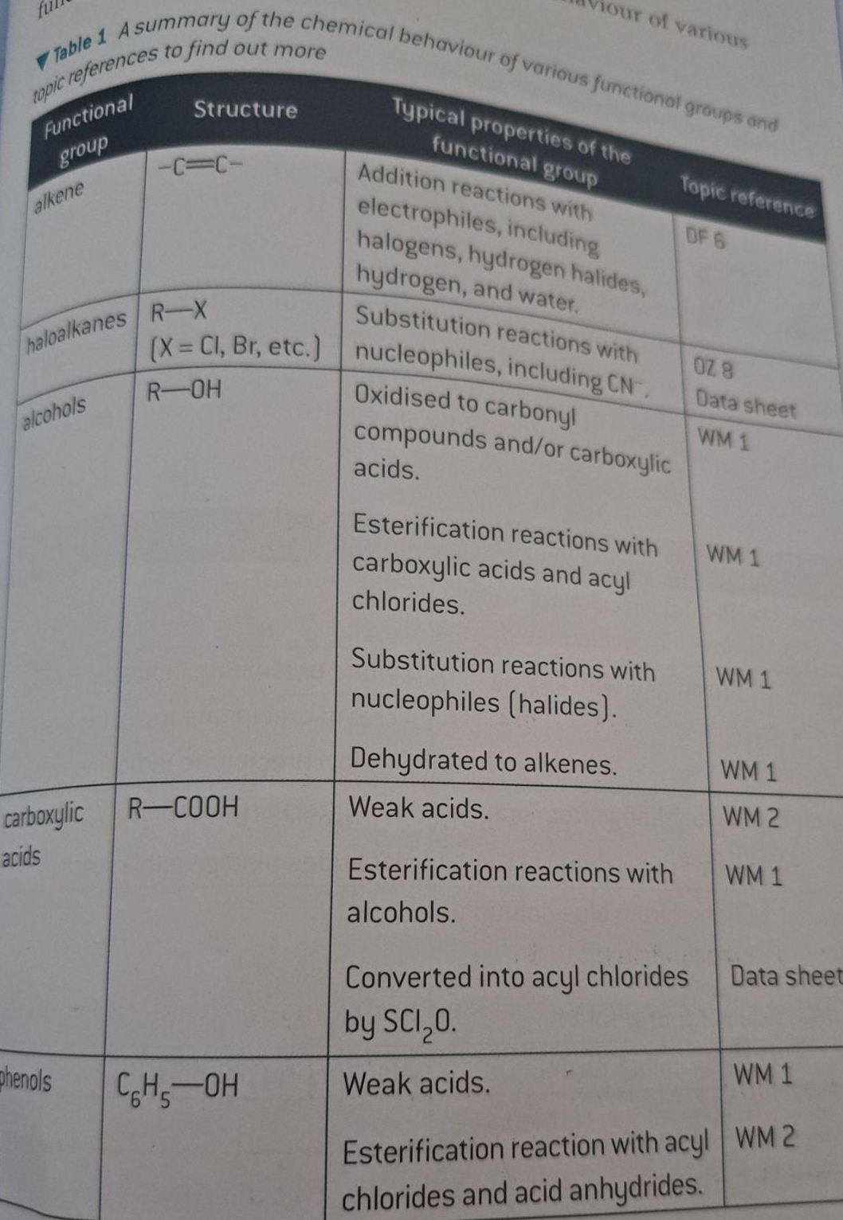
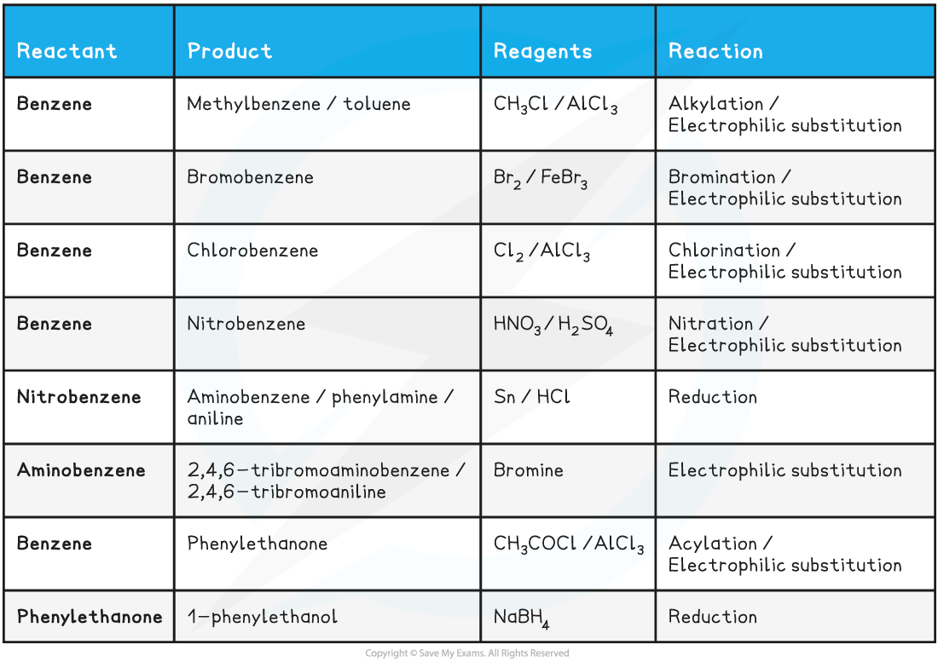
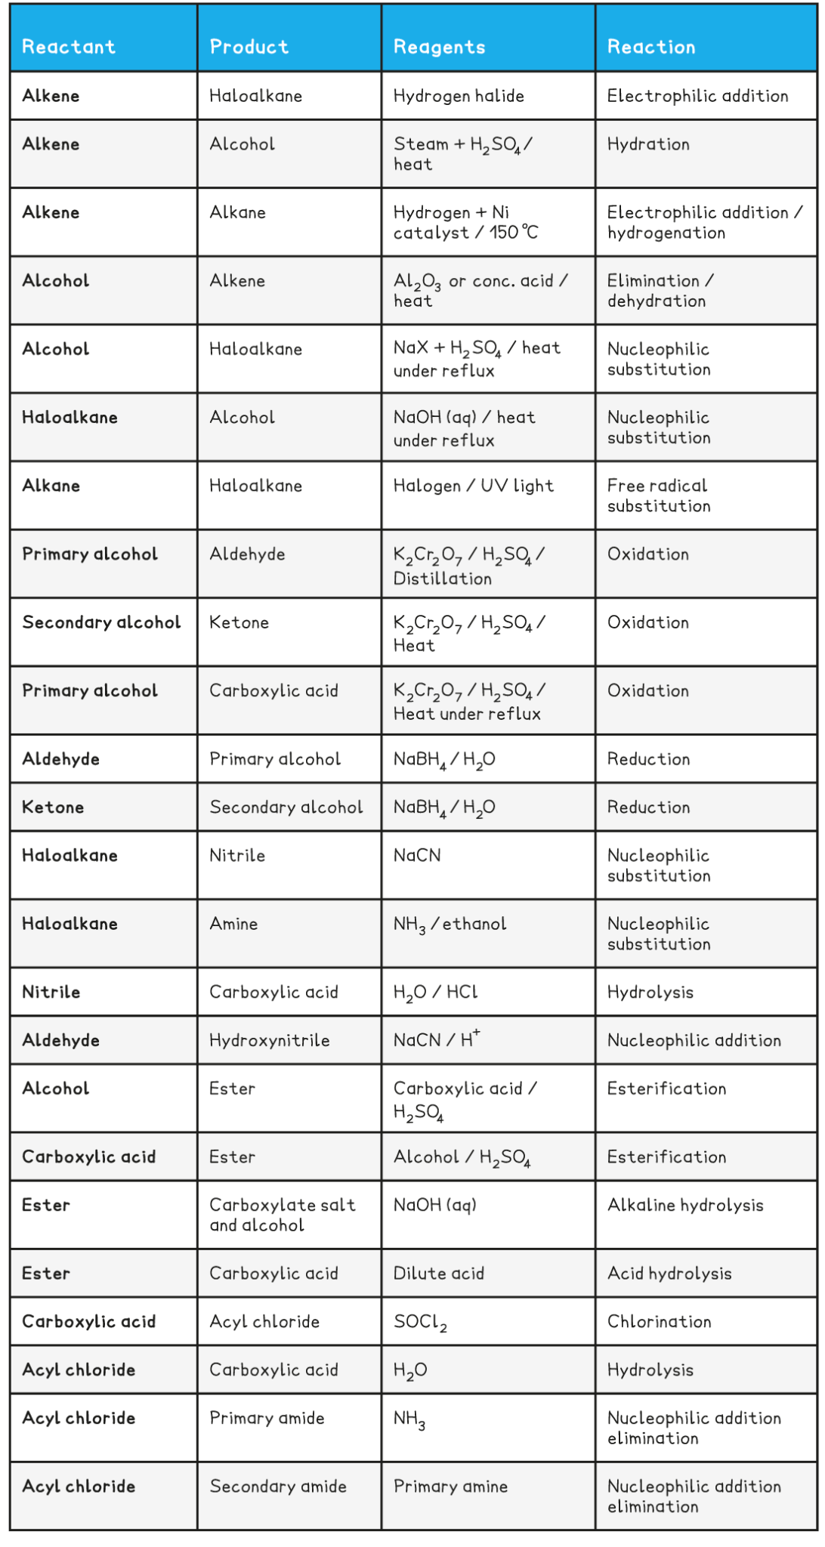

CD.k-l - Reaction mechanisms | CD9 | CD11 |
What is the nucleophilic addition mechanism for the formation of a hydroxynitrile from propanone and HCN? | H⁺ ion from HCN  The negative charge is on the nitrogen

CD.m - Energy & Matter | CD1 |
What are the 3 pairs of complementary colours? | - Red and green  - Blue and orange  - Violet and yellow  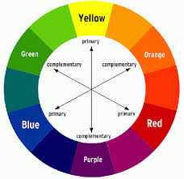  So when a compound absorbs red wavelengths, it transmits (or reflects) the complementary colour green, and so green is what seen  Do not allow ‘emit’ light
Explain why coloured compounds such as dyes are coloured and benzene is colourless (6) [Mr Harbage script] | - Electrons move to a higher energy level by absorbing EM radiation via ΔE=hv (2)  - A dye would have a greater extended system of delocalised electrons (larger chromophore) and so energy levels are closer (as E is smaller) (2)  - Energy absorbed is a lower frequency for dyes (in the VL region), and a complementary colour is transmitted (or reflected) (2)  - Whilst benzene has less delocalisation (smaller chromophore), and energy levels are further apart (2)  - Energy absorbed is high frequency (in the UV) (1)  - Therefore, all visible light is transmitted (or reflected) (1)  - Remember frequency of UV radiation is higher than Visible light radiation [Please say this when comparing colourless and coloured compounds from F335 June 2015]  Do not allow ‘emit’ light AND do not allow E=hv
What are the properties that dyes (coloured compounds) have compared to benzene (colourless) | - Energy levels are closer as they absorb lower freq VL compared to UV  - More Conjugation  - A greater extended system of delocalised electrons  - Larger chromophore  - More than one benzene ring  More than one benzene ring - some Mark Schemes have it, some don’t, your choice whether to say it

CD.n - Modern analytical techniques | CD8 |
Describe the setup of gas-liquid chromatography (GLC)? | 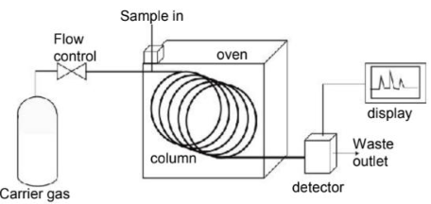  - Mobile phase is a mixture of gas  - Stationary phase is high b.p liquid coating the column
What does the column in GLC consist of? (2) | - High boiling point liquid (1) on a porous support (1)
What are the 2 phases in GL chromatography? | - Stationary phase - liquid on solid support (as in GLC)  - Mobile phase - gas (as in GLC)  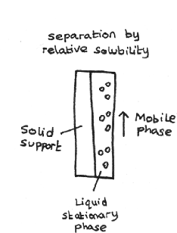
What is the nature of the stationary phase for GLC? (1) | - High boiling point (1)  - Involtatile (1)  - Non-volatile liquid (1)  The stationary phase can also potentially contain solids
Name a suitable substance for the mobile phase for GLC (1) and the property it has (1)? | - Nitrogen (as well as argon but any other named noble gas is NOT ALLOWED) (1)  - Inert (I.e unreactive) (1)  It is also referred to as the carrier gas so look out for this name
How do you interpret a gas chromatogram? | 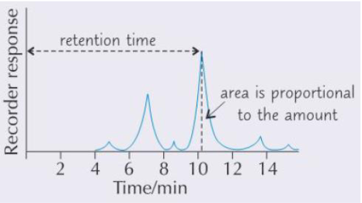  - Time taken to pass via column / retention time is used to identify substance  - Area under each peak is proportional to amount of substance (called peak integration value)  - You would use a ruler to measure the amount of substance
What 5 factors affect retention time? And why? | - Solubility - more soluble compounds will take longer to move via the tube as they would prefer the stationary phase -> higher RT  - Boiling point - a substance with a high boiling point will spend more time turning from a liquid to a gas -> higher RT  - Temperature - high temperature means more evaporated liquid as gas so moves quickly spending more time in the mobile phase -> shorter RT  - Volatility - a more volatile liquid would spend more time in the mobile phase than the stationary -> shorter RT  - Length of column - a longer column would mean longer retention time  When referring to temperature its the temperature of the column not of the substance  These are some examples and so would not represent all the factors
What problems are there with GLC? Why? | Some substances wont separate since they have similar retention factors/retention times because they are structurally similar  It is often used alongside mass spectroscopy

